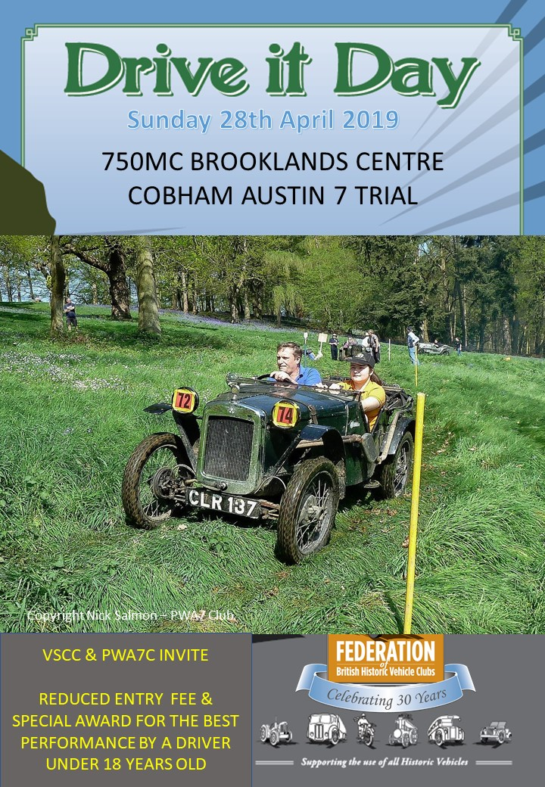

**The Pre-War Austin 7 Club Limited**

**BROOKLANDS CENTRE**

**COBHAM TRIAL**

**SUNDAY 21st April 2024**

**10TH APRIL 2022**

**750MC, VSCC, MCC & FALCON MC INVITEES**

**SPECIAL AWARDS FOR UNDER 18 DRIVERS**

**SUPPLEMENTARY REGULATIONS**

**EVENT - PWA7 CLUB LTD. - COBHAM TRIAL**

**STATUS - CLUBMAN**

**VENUE - COBHAM PARK FARM, SURREY KT11 3ND (M.R. 187/109589)**

**DATE - SUNDAY 21st APRIL 2024**

1. The Brooklands Centre of The Pre-War Austin 7 Club Ltd will organise the “PWA7C Cobham Trial", a MSUK Clubman’s Permit event, at Cobham Park, Cobham Park Road, off Downside Road, Cobham, KT11 3ND on Sunday 21st April 2024.

2. The meeting will be held under the General Regulations of the Motorsport UK (incorporating the provisions of the International Code of the FIA), these Supplementary Regulations and any further instructions that the organising club may issue for the event. The Trial is predominantly held for pre 1939 Austin 7s and their derivatives but any other guest/demonstrations entries are welcomed.

3. Motorsport UK’s Clubman’s Permit No. (to be advised) has been issued for this event.

4. **The event is open to members of the P.W.A.7.C, 750 M.C., V.S.C.C. and M.C.C and Falcon MC**. **(except under 18s – see below)**. **Double entries (i.e. different driver but same car) will be accepted**. **All drivers must also have a front seat passenger (age12+). Passengers over 18 MUST also belong to one of the invited Clubs.**

**All drivers and passengers must sign on (other than those under 18 – see below) and must (if 18 or above) produce a valid RS Clubman’s Licence** (available free of charge on the Motorsport UK website**) and an invited Club Membership Card.**

**Drivers aged 14 to 17 are eligible and must sign on**, but they do not have to be a member of any of the invited clubs nor hold a full DVLA Licence **HOWEVER** **THEY MUST** be accompanied by a passenger who is a member of one of the invited clubs, produces their club membership card, holds a full DVLA Licence, is an experienced Trials Driver and produces a RS Clubman’s Licence.

**Front passengers under 18 (minimum age 12) will not be required to sign on, HOWEVER their names must be entered below and their parent/guardian must give written consent by signing where provided below.**

See para 19(iv) for **rear seat passengers** (permitted in saloons only).

5. The event is not a round of any Championship. This is however the Event's 43rd year having been held nearly every year since 1978 (formerly organised by the 750 Motor Club - Brooklands Centre)

6. PROGRAMME

Signing On and Scrutineering starts from 08.30 at Cobham Park Farm Trial Site.

Marshal’s Briefing will be at 10.15 alongside the signing-on tent.

Drivers’ briefing will be at 10.30 alongside the signing-on tent.

Any competitor not signed on and scrutineered by 10.20 may be excluded.

First car starts at 10.40

Morning session ends at 13.00

Afternoon session starts at 14.00

**DRIVERS WILL NOT BE ABLE TO SIGN ON UNLESS THEY HAVE PASSED SCRUTINEERING.**

7. The Clubman’s Permit and any changes to these Regulations will be clearly displayed at the signing-on tent.

8. There will be at least 2 rounds (usually 3 rounds) usually of 8 sections each, on private land. Details of the sections will be given in the Drivers’ Briefing. Each round must be completed before commencing the next round and the score card must be handed in at the signing-on tent after **each** round. Public roads will not be used to link sections.

9. The event will consist of 5 classes as follows:

1. Austin Seven standard production saloons and tourers
2. Austin Seven unmodified production sports

C. Austin Seven modified saloons and tourers

D. Austin Seven modified sports, specials and others not in A, B or C.

E. Guest cars, or “demonstration cars” i.e. not eligible for the above classes but which must substantially be based on, and comprised of, a chassis and running gear from a car manufactured prior to 1960.

10. All cars must comply with the 2024 MSUK Technical Regulations (as modified in 19. below) and the Scrutineer will ensure the entered vehicle is in the correct class.

11. Competitors will be identified by starting numbers provided by the organisers. These numbers will be issued at signing on.

12. Awards will be presented as follows:

**1st in class** (subject to a minimum of 3 in class)

**2nd in class** (subject to a minimum of 5 in class)

Class awards will be perpetual.

**Challenge Trophy:** Lowest overall score – to be held for one year.

**Roger Boore Trophy**: 1st Production Saloon or Tourer from Class A - to be held for one year.

**Mike Featherstonhaugh Trophy**: for the best newcomer to the Cobham Trial - to be held for one year.

**Tony Jones Memorial Trophy**: awarded to the best “Junior Driver (Age 14-17)” - to be held for one year.

No driver may win more than one returnable award - in such event it will be awarded to the next best.

13. The maximum entry for the meeting is 50; the minimum is 10. The maximum for each class is 30; the minimum is 3. Should any of the above minimum figures not be reached, the organisers have the right to either cancel the meeting or amalgamate classes as necessary.

14.141 **The Driver entry fee is £35.00, with a reduced rate of £15.00 for drivers aged 14 – 17. Please make cheques payable to “PWA7C – Brooklands Centre”.**

**NO FEE IS PAYABLE FOR BEING A MARSHAL. ALL DRIVERS ARE ENCOURAGED TO BRING A MARSHAL WITH THEM (no previous experience required) BECAUSE WITHOUT MARSHALS THE EVENT CANNOT BE RUN.**

**All entries** **must be made on the** **attached official Application Form and accompanied by the appropriate fee (as above) and should ideally be received by 15th April 2024.**

**Driver** e**ntries up to and including the day of the event WILL USUALLY be accepted (at the discretion of the organisers).**

**MARSHAL ENTRIES WILL BE ACCEPTED ON THE DAY.**

Entries will be selected in order of receipt.

15. **The Secretary of the Meeting, to whom all Driver and Marshal entries should be sent, is: Robin Gray, Effingham Lodge, Guildford Road, East Horsley, Surrey KT24 5SB.** [**robingray123@gmail.com**](mailto:robingray123@gmail.com) **Tel: 07734 290813**

**Other Officials are: Club Steward - Colin Weeks**

**Clerk of the Course - Michael Weeks**

**Assistant Clerk of the Course – Andy Currie**

**Chief Marshal – Bev Keable**

**Chief Scrutineer - Roger Horsfield**

16. Provisional results will be published as soon as possible after the end of the event. Any protest or Appeal must be lodged in accordance with Paragraphs C5.1 and C6.1 of the Motorsport UK 2024 Yearbook General Regulations (the “Yearbook”).

18. Marking and penalties will be performed in accordance with Paragraphs T6 and T7 respectively of the Yearbook unless modified in these regulations. Copies of the scoring system will be available at signing-on and a further copy held by each marshal.

19. All other General Regulations of Motorsport UK apply as written, except for the following:-

1. All competing vehicles in classes A to D shall be Austin Seven powered and have a wheelbase of 6' 3" or 6' 9". Each vehicle shall be capable of being road registered and shall display registration number plates.

Tyres need to be in accordance with the Yearbook clauses T 10.9 -10.10 and well-base tyres must have a tread pattern such that the blocks are not more than 10mm deep, nor more than 10mm apart laterally or circumferentially. There must not be an uninterrupted lateral gap between side blocks. Special grip, knobbly or hand-cut tread tyres are not allowed. Tyres with bolts or screws penetrating the sidewalls or beads or operational security bolts are not be allowed.

Tyre pressures must be not less than 7 p.s.i., or as specified by the organisers.

1. **Austin Seven Production Cars**. Cars will be deemed to be Austin Seven Production cars for the purpose of this event if they comply with 19(i) and the following conditions are met:

a) Cars must have bodies (or reproductions thereof, but not g.r.p.) made by the Austin Motor Co. 1922-1939 as standard equipment to Austin Seven cars (proprietary coach built bodies of the era included).

b) Cars must be fitted with braking systems acting together on all four wheels or two independent braking systems i.e. one acting on front wheels simultaneously and the other on rear wheels simultaneously.

c) Cars must be fitted with Austin Seven front axle and stub axles with unmodified lockstops.

d) Cars must be fitted with overall gear ratios to the original specification.

e) Cars must be fitted with Austin Seven inlet/exhaust manifolding.

f) Cars must be fitted with Austin Seven wheels (see iii below) a spare wheel must be carried.

1. All cars in Classes A to D must be fitted with original Austin Seven wheels appropriate for the original type and model of car entered. Any car not complying with this regulation will be reclassified as a demonstration car i.e. Class E.
2. Seating. The rearmost part of the front seats must not be behind the rear wheel axis. All cars running in Classes A - D must have two front seats **AND** carry a passenger of 12 years of age or over in the front passenger seat. Children aged 2 years and above are allowed in the rear seats of saloons (only) but if under the age of 12 years or 135cm in height **must be restrained in an appropriate child restraint** (Yearbook T4.1.6).
3. It is recommended that cars should be fitted with an extra throttle return spring, that the battery be properly secured, and that a fire extinguisher and spill kit be carried.
4. Any wet batteries in the driver/passenger compartment should be located behind the base of the driver/passenger seat and enclosed in a securely located leak-proof container in accordance with Yearbook J5.14.1

20. **Important:**

**The speed limit for all vehicles on the site (except those officially competing on a section) is 10 MPH.**

**Dogs (but no other animals) may be taken onto the site BUT MUST BE FULLY HARNESSED AND CONTROLLED AT ALL TIMES.**

**All persons entering the site must remain within the** **stipulated areas and observe “Out of Bounds” and other warning signs at all times.**

**PRE WAR AUSTIN 7 CLUB LIMITED – COBHAM TRIAL – 21 APRIL 2024**

**DRIVER AND PASSENGER APPLICATION FORM**

**NAME OF ENTRANT**………………………………………………………… Is this your first Cobham Trial? Yes / No

**ADDRESS** ………………………………………………………………………………………………………

**TELEPHONE** …………………………………… **E-MAIL** …………………………………………………… being a fully paid-up member of the PWA7 Club, or an invited Club. CLUB ………………………MEMBERSHIP NO:…….…

CAR MAKE …………………………………………… MODEL ………………………………

REGISTRATION NO. ……………………………YEAR ………………..……………DOUBLE ENTRY? Yes / No

TYRE SIZE & TYPE …………………..………… CLASS ENTERED …………………..

I declare that:

1. **I understand that I will be required, at signing-on, to produce my Club membership card and MSUK Clubman’s Licence and that I will be required to sign an indemnity in accordance with D13.1 of the Yearbook.**

2. I have been given an opportunity to read the General Regulations of the Motorsport UK (including D 13.1 of the Motorsport UK Yearbook 2024) and the Supplementary Regulations for this event and agree to be bound by them. I declare that I am physically and mentally fit to take part in the event and I am competent to do so. I acknowledge that I understand the nature and type of the competition and the potential risk inherent with motor sport and agree to accept that risk. Further I understand that all persons having any connection with the promotion and/or organisation and/or conduct of the event are insured against loss or injury caused through their negligence.

3. If I am the Parent/Guardian/Guarantor of either the driver or passenger I understand that I shall have the right to be present during any procedure being carried out under the Supplementary Regulations issued for this event and the General Regulations of Motorsport UK

Note: Where the Parent/Guardian/Guarantor is not present there must be a representative who must produce a written and signed authorisation to so act from the Parent/Guardian/Guarantor as appropriate.

**ENTRANT** **SIGNATURE**……………………………………AGE (if under 18)……………..DATE………………………….

**I WILL/WILL NOT BE BRINGING A MARSHAL WITH ME.**

**SECOND DRIVER NAME (printed) ………………………………………………SIGNATURE……………………………**

CLUB**……………………**MEMBERSHIP NO:….**………….**AGE (if under 18)**…………………..**DATE**……………………**

**PASSENGER NAME** (printed).……………….…………………..**PASSENGER** **SIGNATURE** (if over 18)……………….

CLUB…………………MEMBERSHIP NO:……………PASSENGER AGE if under 18 years (front passenger minimum 12 years)…………

**If driver or passenger is under 18 years we require the counter-signature(s) of their parent/guardian**

**I agree to the above-named under 18 year old(s) participating as driver or passenger subject to the terms above**

PARENT/GUARDIAN NAME (printed) …………………………………

ADDRESS …………………………………………………………………………..

SIGNATURE ……………………………Parent/Guardian signing on behalf of…………………………….(name of minor)

**Relatives or friends OF DRIVER AND PASSENGER(S) to be contacted in case of a serious accident**

**Names: Telephone nos:**

**PRE WAR AUSTIN 7 CLUB LIMITED – COBHAM TRIAL - 21 APRIL 2024**

**MARSHAL APPLICATION FORM**

Held under the General Regulations of the Motorsport UK (incorporating the provisions of the International Sporting Code of the FIA and these Supplementary Regulations

NAME ……………………………………………………………… Is this your first Cobham Trial? Yes / No ADDRESS ……………………………………………………………………………………………………… TELEPHONE …………………………………… E-MAIL …………………………………………………

I declare that:

**1. I fully understand that I will have to sign an Indemnification Form as specified in G13.1 of the 2024 Motorsport UK’s Yearbook before I will be able to take up my position.**

**2. I understand that I will be undertaking my duties at my own risk and will not go any nearer to the course than I have to in order to perform my duties. I also understand that, if I haven’t already done so, I will be given an opportunity to read the General Regulations of the Motorsport UK and the Supplementary Regulations for this event and agree to be bound by them. I declare that I am physically and mentally fit to take part in the event and I am competent to do so. I acknowledge that I understand the nature and type of the competition and the potential risk inherent with motor sport and agree to accept that risk. Further I understand that all persons having any connection with the promotion and/or organisation and/or conduct of the event are insured against loss or injury caused through their negligence.**

Date ..................……....………...........…............... Signature ……………………………………...

AGE (if under 18)………………………………

**If Marshal is under 18 years of age we require the counter-signature of your parent / guardian**:

Name PRINTED………………………… Address …………………………………………………………………………..

Signature ……………………………………… Parent/Guardian (please delete as necessary)

Relative or friend to be contacted in case of a serious accident (if not Parent or Guardian):

Name …………………………… Contact Details ……………………………………………………….…...

**Please return completed Driver/Passenger and Marshal Application Forms and cheques (if applicable) payable to “PWA7C – Brooklands Centre” to:**

**Robin Gray, Effingham Lodge, Guildford Road, East Horsley, Surrey KT24 5SB**

**All Driver/Passenger and Marshal Application Forms received by the Secretary will be acknowledged by email (only) provided an email address has been given.**